May 16, 2024

LawyerFirst LawyerLast Esquire

SampleFirmName

123 Address St.

CityVille, StateLand 12345

Tel: (012) 345-6789

RE: *Pl1FirstName Pl1LastName; Pl2FirstName Pl1LastName; ThirdOne ThirdName et al. v SampleCaseDefendantName et al., Case No: CaseNoSample, SampleCourtName*

Date of Crash: January 1, 2020

Date of Birth: *Pl1FirstName Pl1LastName:* January 1, 1999 [20 years old at time of crash]

*Pl2FirstName Pl1LastName:* January 2, 1990 [29 years old at time of crash]

*ThirdOne ThirdName:* January 4, 1994 [25 years old at time of crash]

Dear Mr. LawyerLast,

I am in receipt of your correspondence regarding the above-named action. I have reviewed the documentation accompanying your correspondence including medical records, information regarding the subject crash, litigation documents, and other materials.

The purpose of this report is to provide an analysis of the causal relationship between the subject rear impact collision and Ms. and Mr. Pl1LastName and Mx. ThirdName’s subsequently diagnosed shoulder injuries and need for treatment.

*My qualifications to provide opinions concerning the matters herein, particularly on issues of the causal relationship between trauma and injury, are as follows:*

I am Professor and Chair of Forensic and Legal Medicine with the Faculty of Forensic and Legal Medicine of the Royal College of Physicians (UK), and a consultant in the fields of forensic medicine and forensic epidemiology. I am credentialed as a Fellow of the Royal College of Pathologists (UK), Fellow of the Faculty of Forensic and Legal Medicine (FFLM) of the Royal College of Physicians (UK) and member of the British Association in Forensic Medicine. I hold the following relevant academic degrees and certifications: a Doctor of Medicine degree (Med.Dr.) from Umeå University, a Doctor of Philosophy (Ph.D.) in public health/epidemiology from Oregon State University, a Master of Public Health (MPH) in epidemiology and biostatistics, also from Oregon State University, a master’s degree in forensic medical sciences (MScFMS) with the Academy of Forensic Medical Sciences in the United Kingdom, i.a. In addition to my degreed education, I have completed a 2-year post-doctoral fellowship in forensic pathology at Umeå University in Sweden and hold a Diploma of Legal Medicine (DLM) with the FFLM. I am also a fellow of both the American Academy of Forensic Sciences and the American College of Epidemiology. I am a Fulbright Fellow and held a 3-year roster appointment (2017-20) with the United States Department of State as a Fulbright Specialist in the field of forensic medicine. I serve as tenured Associate Professor of Forensic Medicine at Maastricht University and a joint Clinical Professor of Psychiatry and Public Health and Preventative Medicine at Oregon Health and Science University School of Medicine, where I have taught courses for the past 24 years in forensic medicine, forensic epidemiology, and injury epidemiology. From 2005-2017 I held an appointment as an Adjunct Professor of Forensic Medicine and Epidemiology at the Institute of Forensic Medicine, Faculty of Health Sciences, Aarhus University, Aarhus, Denmark, and am a recent (2020-21) visiting professor at University of Indonesia in the Faculty of Medicine.

I have been a crash reconstructionist since 1996 and have had ACTAR accreditation (the Accreditation Commission on Traffic Accident Reconstruction) since 2005. Over the past >25 years I have participated in the reconstruction of more than 3,000 crashes, including more than 300 fatalities. From 1999 through 2007 I served as a vehicular homicide investigator for law enforcement (consultant to the state medical examiner and special deputy sheriff), and I am a former affiliate medical examiner with the Allegheny County Medical Examiner’s office.

I am a member of the American Society of Biomechanics and have more than 60 scientific publications pertaining to injury biomechanics, including a book for the Society of Automotive Engineering and taught injury biomechanics in a faculty peer-reviewed course at OHSU for 15 years. I have served as a consultant on injury biomechanics to state and federal government.

I am an associate editor of the Journal of Forensic and Legal Medicine and serve or have served as an associate editor or editorial board member of 14 additional scientific peer-reviewed journals. I have published approximately 230 scientific papers, abstracts, book chapters and books on topics that include traffic crash injuries, crash reconstruction, injury causation and injury biomechanics, including the text for Elsevier, Forensic Epidemiology: Principles and Practice (2016). My publications have been cited by other authors more than 4,700 times.

I have provided testimony in more than 400 civil and criminal trials in state and Federal courts throughout the United States, Canada, and Australia. Please see my CV for further details.

*Post-crash history, Pl1FirstName Pl1LastName (driver)*

*Post-crash history, Pl2FirstName Pl1LastName (front passenger)*

***Injury Causation Analysis***

A crash-related injury causation analysis for a specific individual is performed by assessing the risk of injury from the collision and comparing it to the probability that the injuries or conditions would have been present at the same point in time if the collision had not occurred. The process is referred to as a "3-step" injury causation method in which improbable alternative causes are ruled out and the single most likely cause is identified. The analysis is accomplished via the application of crash reconstruction, biomechanical, medical, and epidemiologic (risk assessment) principles.[1],[2] This 3-step methodology has been extensively described in the peer-reviewed literature, been deemed generally accepted by Courts in the United States, and has been adopted as part of case law in the U.S.[3],[4] See the Appendix at the end of this report for more information.

The three fundamental elements or steps of an injury causation analysis are as follows:

Whether the injury mechanism had the potential to cause the injury in question (aka general causation);

The degree of temporal proximity between the injury mechanism and the onset of the symptoms reasonably indicating the presence of the injury; and

Whether there is a more likely alternative explanation for the occurrence of the symptoms at the same point in time (aka differential etiology).

As applied to the facts in the subject case, these 3 steps are as follows:

*Reconstruction of the crash*

*Injury biomechanics*

The rear impact would have resulted in Ms. and Mr. Pl1LastName and Mx. ThirdName’s torsos and heads initially being thrown rearwards into the seatback at around 5-6 mph, and then rebounding forward into the restraining seat belt and toward the steering wheel. Ms. and Mr. Pl1LastName and Mx. ThirdName would have sustained substantial complex loads on their spines in the collision, loads that include compression, rotation, and shear all occurring at the same time and to varying degrees in less time than it takes to blink an eye (around 250 msecs). The load on their left shoulders, when they were restrained by the shoulder belt, would have likely exceeded several hundred lbs. The peak cervical, thoracic, and lumbar spinal disk loads could have ranged from 150 to 400 or more lbs., respectively, more than sufficient to cause a wide range of musculoligamentous and skeletal injuries.

While a 5-6 mph rear impact collision may not sound like a very significant event, such collisions can result in surprisingly violent occupant movement. This concept is more easily understood from a series of video still shots, reproduced below, from a rear impact collision crash test conducted at 5.2 mph delta V (the same as estimated for the subject crash), and resulting in no vehicle damage. The occupant depicted in the test sustained a measured 12.5 g of peak head acceleration:

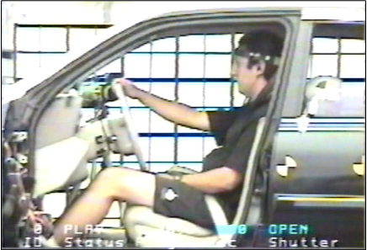

Time = 0 msec: Occupant in neutral position at time of impact. Note the distance between the knee and the front of the seat.

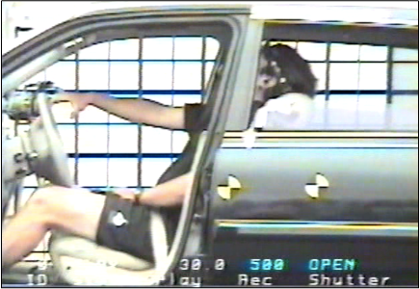

Time = 175 msec: The occupant’s torso completely compresses the seatback and the head and neck are at maximum extension. The hand comes off the steering wheel and the distance between the knee and the front of the seat now increases, as the hips begin to rebound forward ahead of the torso and head, indicating shear forces in the low back.

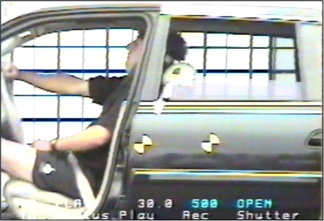

Time = 200 msec: The occupant’s torso and head begin to rebound off of the compressed seatback. His right hand strikes the steering wheel and his knees move toward the dashboard.

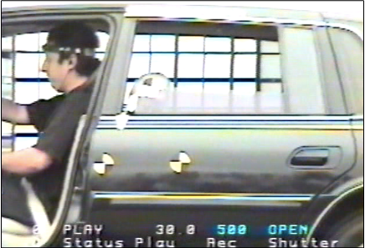

Time = 250 msec: The occupant is projected forward past his pre-crash position in the vehicle and loads the now locked shoulder belt with his left shoulder.

The stills were part of a peer-reviewed research publication that I co-authored, which I will make available for demonstrative purposes upon request.[5],[6]

The crash testing and epidemiologic literature provides good information regarding the forces associated with a 5-6 mph rear impact delta V crash, which can be quite substantial. A recently published analysis of the world literature on the topic demonstrated the distribution of body accelerations and injury risks illustrated in the charts below:

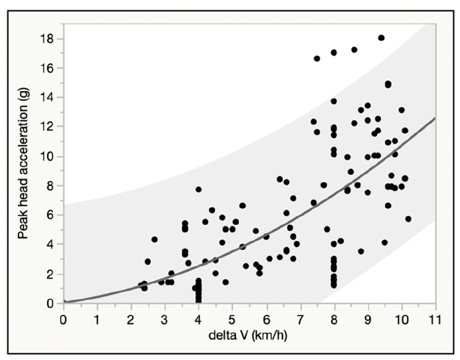

Chart showing the relationship between a 5-6 mph delta V rear impact and peak head acceleration measured in 126 volunteers. The red band shows the magnitude of the crash Ms. and Mr. Pl1LastName and Mx. ThirdName were exposed to. As demonstrated in the chart, peak head accelerations can exceed 17g (17 times the forces of gravity). Note: 5-6 mph is approximately equal to 8 to 10 km/h on the chart.

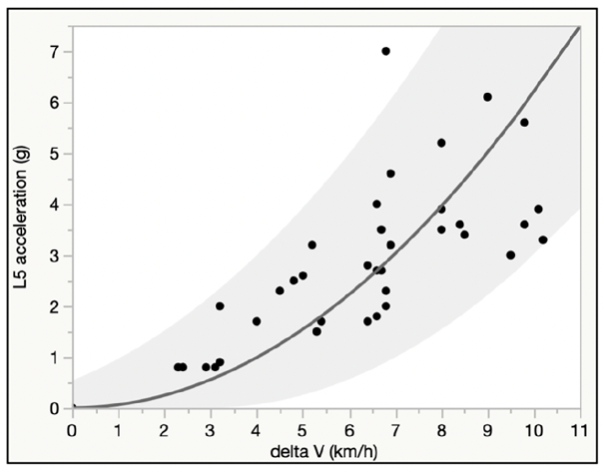

Chart showing the relationship between a 5-6 mph delta V rear impact and peak low back acceleration measured in 39 volunteers. The red band shows the magnitude of the crash Ms. and Mr. Pl1LastName and Mx. ThirdName were exposed to. As demonstrated in the chart, peak low back accelerations can exceed 7g (7 times the forces of gravity). Note: 5-6 mph is approximately equal to 8 to 10 km/h on the chart.

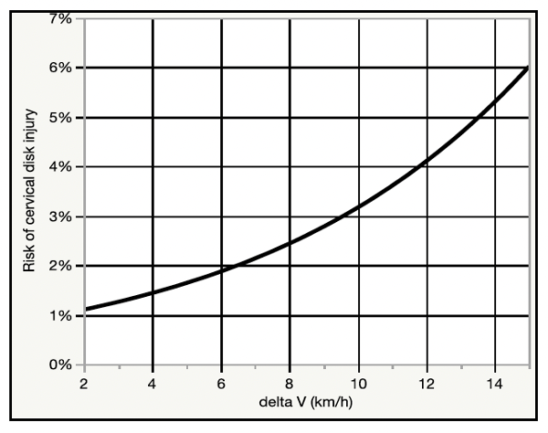

Chart showing the relationship between a 5-6 mph delta V rear impact and cervical disk injury risk observed in 113 people exposed to real-world crashes. The red band shows the magnitude of the crash Ms. and Mr. Pl1LastName and Mx. ThirdName were exposed to. As demonstrated in the chart, the risk of a cervical disk injury ranges from 2.5 to 3.2% or around 1 in 31 to 1 in 40. Note: 5-6 mph is approximately equal to 8 to 10 km/h on the chart.

The types of shoulder and spinal injuries that Ms. and Mr. Pl1LastName and Mx. ThirdName was diagnosed with (a SLAP lesion and cervical and thoracic disk derangements) are consistent with the injury mechanism of the crash. The sheer forces exerted on Ms. and Mr. Pl1LastName and Mx. ThirdName’s left shoulder by the shoulder belt (or possibly transmitted by transferred forces through Ms. and Mr. Pl1LastName and Mx. ThirdName’s grip on the steering wheel), would have had the potential to cause the SLAP lesion diagnosed by Dr. Doctor. This is one of the reasons that the American Academy of Orthopedic Surgeons lists traffic crashes prominently as one of the causes of SLAP lesions, along with falls, sports involving overhead movement, and dislocations. The risk of SLAP lesions is closely associated with age, and women in Ms. and Mr. Pl1LastName and Mx. ThirdName’s age group are at nearly **3** times the risk of the injury as women in their 20s, regardless of activity. This is due to the normal wear and tear-related degenerative changes that occur in the shoulder over time, which has the tendency to make the shoulder more susceptible to injury in the event of a sudden traumatic load. There is no lower threshold of crash force for causing a SLAP lesion; any force that could cause a strain could also potentially cause a SLAP lesion, as the same structures are loaded regardless of the diagnosis. A study of rear impact crashes with an average delta V of 4 mph reported that around 1 in 10 subjects had persisting symptoms and diagnosis of shoulder injury at 5 or more weeks post-crash.

The types of spinal injuries that Ms. and Mr. Pl1LastName and Mx. ThirdName was diagnosed with (primarily symptomatic disk derangements in the neck and middle back) are highly consistent with the injury mechanism of the crash as well. Traumatic loading of the spine that results in axial (up and down) compression, particularly in combination with the other load types occurring with the subject collision, has the potential to damage the peripheral disk annulus, which surrounds and holds in the disk nucleus. Women in their early 3rd decade like Ms. Pl1LastName typically have asymptomatic age-related degenerative changes of the disks of the spine, a factor that increases the risk of injury in the event of the crash like the subject rear impact.

Although the subject crash was no mere "bumper tap", traumatic spinal disk injuries do not require excessive levels of force. Traumatic disk injuries have been described in the peer-reviewed literature as resulting from low to moderate force events, including minimal or no damage traffic crashes, roller coaster rides, and even more mild forces such as sneezing.[7]-[8][9][10][11][12][13] It is accurate to state that there is no established or generally accepted lower force threshold at which it can be said that an acute intervertebral disk injury in any part of the spine cannot occur.

Based on the preceding discussion there was ample and biomechanically appropriate force exerted on Ms. and Mr. Pl1LastName and Mx. ThirdName’sbodies in the subject collision to have caused their medically documented injuries, and associated need for evaluation and treatment, including their left shoulder SLAP repair surgery, etc.

Shoulder three steps placeholder

**Conclusions**

Given the contiguous chain of causation from the day of the crash through Ms. and Mr. Pl1LastName and Mx. ThirdName’s most recent medical records, the lack of any significant pre-crash history of persisting spine pain and need for treatment in the years prior to the crash, as well as the relative risk of significant and persisting spine injury from the subject frontal impact crash, I conclude that the most probable cause of the post-crash acute and chronic neck and low back injuries described in Ms. and Mr. Pl1LastName and Mx. ThirdName’s medical records and summarized in this report, including their symptomatic cervical and lumbar disk derangements, is the subject January 1, 2020 frontal impact crash.

I have examined neither Ms. nor Mr. Pl1LastName nor Mx. ThirdName and I therefore have no opinions about their diagnoses, treatment, or prognoses outside of what is reflected in the medical record. This is not to say that I am not qualified, licensed, and extensively experienced in performing such evaluations, but that I have not done so in this case.

The preceding opinions were given as reasonable medical, and scientific probabilities. I reserve the right to amend any of my opinions should new information come to light.

Very truly yours,

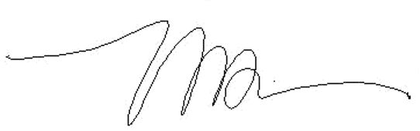

Michael D. Freeman, MedDr, PhD, MScFMS, MPH, FRCPath, FFFLM, FACE, DLM

**David Jenkins Memorial Professor and Chair in Forensic and Legal Medicine**  
Faculty of Forensic and Legal Medicine, Royal College of Physicians (London, UK)  
  
**Associate Professor of Forensic Medicine,**  
Care and Primary Healthcare Research Institute, Faculty of Health, Medicine, and Life Sciences, Maastricht University, Maastricht, Netherlands  
  
**Clinical Professor of Forensic Psychiatry**  
Department of Psychiatry, School of Medicine, Oregon Health & Science University  
  
Fellow, Royal College of Pathologists (UK)  
Fellow, Faculty of Forensic and Legal Medicine, Royal College of Physicians (London, UK)  
Fellow, American College of Epidemiology  
Member, American Society of Biomechanics

1. Melia P et al. Development of the INFERENCE (INtegration of Forensic Epidemiology and the Rigorous EvaluatioN of Causation Elements) approach to causal inference in forensic medicine. Int J Environ Res Public Health 2020;17:8353; doi:10.3390/ijerph17228353.
2. Freeman MD. A practicable and systematic approach to medicolegal causation. Orthopedics 2018;41(2):70-2.
3. Freeman MD, Centeno CJ, Kohles SS. A systematic approach to clinical determinations of causation in symptomatic spinal disc injury following motor vehicle crash trauma. PM R 2009;1(10):951-6.
4. Etherton v. Owner Insurance Company. U.S. District Court of Appeals, 10th Circuit. Case No. 14-1164.
5. Croft AC, Haneline MT, Freeman MD. Low speed frontal crashes and low speed rear crashes: is there a differential risk for injury? Annu Proc Assoc Adv Automot Med. 2002;46:79-91.
6. Croft AC, Herring P, Freeman MD, Haneline MT: The neck injury criterion (NIC): future considerations. Accid Anal Prev 2002;34(2):247-55
7. Giuliano et al. The use of flexion and extension MR in the evaluation of cervical spine trauma: initial experience in 100 trauma patients compared with 100 normal subjects. Emerg Radiol. 2002;9(5):249-53.
8. Freeman et al. Significant spinal injury resulting from low-level accelerations: A case series of roller coaster injuries. Arch Phys Med Rehab 2005;86:2126-30.
9. Lutz et al. CT myelography of a fragment of a lumbar disk sequestered posterior to the thecal sac. Am J Neuroradiol 1990;11(3):610-1.
10. Sadanand et al. Sudden quadriplegia after acute cervical disc herniation. Can J Neurol Sci 2005;32(3):356-8.
11. Pappas et al. Outcome analysis in 654 surgically treated lumbar disc herniations. Neurosurgery 1992;30(6):862–6.
12. Smith J. An analysis of 72 real world impacts - an initial investigation into injury and complaint factors. SAE Technical Paper 1999-01-0640.
13. Freeman MD. Medicolegal causation analysis of a lumbar spine fracture following a low speed rear impact traffic crash. J Case Rep Prac 2015; 3(2): 23-9.